**Department of Computer Science**

**M.Sc. Computer Science I**

**SEMESTER II**

**Synopsis**

**Group Members:**

Name & Roll No: Mali Ganesh Rajendra (246209).

Name & Roll No: Dhavale Ajinkya Balasaheb (246202).

Name & Roll No: Pasalkar Vaibhavi Sanjay (246260).

**Title of the Project:** Academic Certificate Generator.

**Description:**

This project focuses on creating a platform to automate the process of requesting, generating, and managing certificates. By streamlining these tasks, the platform helps reduce manual effort and ensures a more efficient, transparent system for students, administrators, and departmental staff. Students can easily request certificates, track notifications, and collect them, while administrators and departments like Library, Accounts, and Scholarship handle verification and approvals. Additionally, the platform supports real-time updates, ensuring that all parties have access to the most accurate information. It also helps in maintaining a secure and centralized database for certificates, reducing the risk of data loss or inaccuracies. The system enhances decision-making and provides a seamless user experience, offering easy access to important information and generating insightful reports for a better educational experience.

**Functionalities:**

* Manages user access based on predefined roles (Student, Admin and Department like Library, Account, Scholarship).
* Student Request certificates like transfer certificates, Bonafide Certificate, etc. Track certificate status through notifications. Collect generated certificates.
* Allow students to upload supporting documents for certificate requests.
* Administrator verify and approve certificate requests. Generate certificates based on student requests.
* Departments manage specific tasks (e.g., Library for library clearances, Accounts for fee clearances). Ensure smooth verification and approval processes.
* Centralized database for storing and managing certificates.
* Seamless, easy-to-use interface for students, administrators, and departmental staff.
* Generate reports on certificate requests, approvals, and completions.

**Flowchart of Application:**

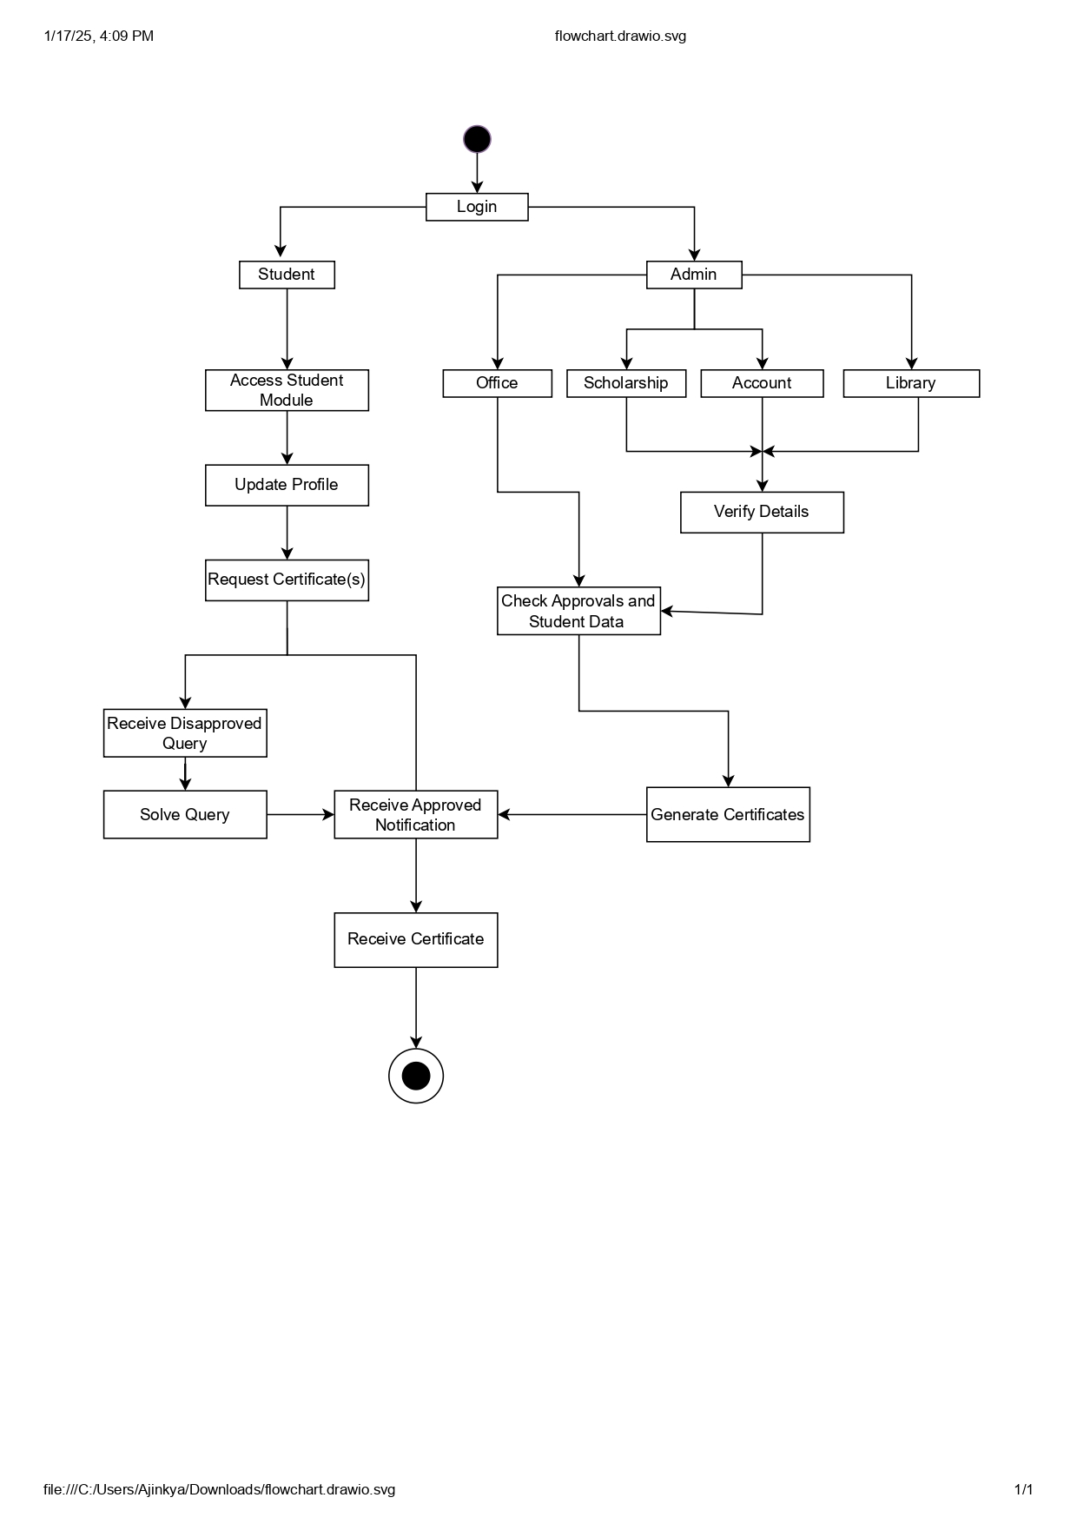

**Modules:**

* **Student Module**
* **Login and Dashboard Access** : Students log in using secure credentials to access a personalized dashboard. It provides an overview of pending requests, approved certificates, and notifications.
* **Profile Management** : Students can update their personal details such as name, address, contact information, and academic details. Allows uploading of necessary supporting documents (e.g., ID proof, academic records).
* **Certificate Request Submission** : Students can request various types of certificates, such as Bonafide Certificate, Transfer Certificate ,etc.
  + Request Tracking : Students can monitor the status of their requests in real time: Pending: Awaiting admin verification.
  + Approved: Ready for collection/download.
  + Disapproved: Rejected due to specific.
* **Query Resolution**: If a request is disapproved, students can view the reason in their dashboard. Once resolved, students can resubmit the request for verification.
* **Document Management** :
* The system allows students to upload, update, and manage documents required for certificate requests.
* Approved certificates are made available for digital download directly through the portal.
* For physical copies, students are notified of the collection date and location.
* Ensures secure handling of payments for certificate **processing fees**.
* **Admin Module**
* **Login and Dashboard Access** : Admins log in securely to access their personalized dashboard. The dashboard displays pending certificate requests, approved and disapproved certificates, Notifications and reminders.
* **Request Verification** : Admins review and validate certificate requests submitted by students. Verification involves cross-checking details against records in the following submodules:
* **Office**: Validates general student data.
* **Scholarship**: Checks scholarship if any.
* **Account**: Ensures no outstanding fees or financial dues.
* **Library**: Confirms there are no pending book returns or fines.
* **Approval/Disapproval.**
  + Approval : Verified requests are approved, certificates are generated, and students are notified.
  + Disapproval: Requests with errors or incomplete details are rejected, with specific reasons and instructions provided to students.
* **Certificate Generation** : Once approved, the system automatically generates the requested certificates. Review generated certificates for quality assurance.
* **Query Management** : Admins handle queries raised by students related to disapproved requests. They can review resubmitted requests after students address the issues.

**Technologies:**

* **Frontend** : HTML, CSS, Bootstrap, JavaScript.
* **Middleware** : Spring Boot.
* **Application Database** : MySQL.